Training material on ICT tools to develop and adapt OER

Authors: Vida Žvinienė, Marius Šadauskas, Airina Volungevičienė, LieDM Association
Contributors: OpenProf partners

Having successfully completed all training material, you will be able to:
- set the requirements for ICT tool for OER development/adaptation
- choose ICT tool for OER development/adaptation according the functionality
- develop/adapt OER using selected ICT tool
- choose the license and mark developed/adapted OER with CC license:

Unit 1. Requirements for ICT tools for OER development/adaptation

This Unit focus on requirements for ICT tools for OER development/adaptation. Having successfully completed this Unit, you will be able to:
- set the requirements for ICT tool for OER development/adaptation
During Assignment 1 you will set the requirement that will help you to choose the ICT tool for your OER development/adaptation.

1.1 Overview of requirements for ICT tools for OER development/adaptation

OER can include full course, article, textbook, presentation, picture, mindmap, slideshow, animation, music, video, game, test or any other educationally useful materials. There are different ICT tools for developing all these OER, e.g. one tools are used to develop text document and another ones are used to develop video material. That means that before selecting the ICT tool for developing your OER you have to decide what will be the type of your OER. The ICT tool suitable for this OER type should be selected. In this training material we will focus on the ICT tools for developing/adapting these OER types:
- document
- presentation
- collaboration
- video/ audio

The next step is to think about the requirements for ICT tool. What functionality from the tool do you need in order to develop/adapt your OER? For example, if you are going to develop the slideshow presentation using online tool and already have a draft version in MS powerpoint format, it could be important that the tool would have the function of uploading existing MS powerpoint file function. If you are going to develop the presentation together with your colleagues, you will need a tool allowing collaborate with other people online. Before searching for ICT tool for your presentation you could also think about:
- will you need formatting functions (various text formats, colors, etc.)?
- will you need to add pictures to presentation?
- will you need pictures library where you can find images for your presentation? Images with Creative Commons licences?
- will you need embedding slideshow presentation to blogs, webpages, etc.?
- would you like that the tool would allow to export slideshow as a PDF, PPT or other formats?
- what other functions of ICT tool do you need?
Another kind of requirements could be setted for OER in video format. You could need such ICT tool functions as combining several videos, cutting the video or adding subtitles. In chapter 1.2 you will find the templates for setting requirement for different types of OER.

As you are creating OER you should also think about re-using it. It is important that other people could download and, if licence allows, edit it. Choosing ICT tool for your OER development you should think about editability options:
- will the ICT tool allow to download OER in editable version?
- will the ICT tool allow to edit OER online?
- will the ICT tool allow to edit OER for registered users?
- will the ICT tool allow to edit OER without registration
- will the ICT tool allow to edit OER collaboratively

Before choosing the ICT tool for developing your OER you should also think about usability and accessibility issues. Otherwise you could select ICT tool that perfectly meets your requirements for functionality, but it is very expensive or too complicated to use. Setting the requirement for the ICT tool you should also take into account:
- is the ICT tool free of charge?
- is it intuitive to use?
- how attractive it is?
- can you add Creative Commons license on you work?
- what operating systems does the ICT tool support?
- is any other requirements for usability and accessibility?

1.2 Setting the requirements for ICT tool for OER development/adaptation

In this chapter you will find the Assignment and templates that will help you to set the requirements for ICT tool.

Assignment 1. Setting the requirements for ICT tools for OER.
The aim of the assignment: having implemented this assignment, you will be able to decide on requirements for ICT tool for developing/adapting your OER. This will help to choose the ICT tool later.
Tasks:
- select what will be the type of your OER (document, presentation, collaboration, video/ audio or other)
- set the requirements for functionality of ICT tool and requirements for OER editability. You can use the templates below marking the requirement and writing your comments. If you are developing another type of OER, these templates could serve as an example for you. Using them you can develop your own template for setting the requirement for your OER.
- specify the requirements for accessibility and usability of ICT tool. You can write your comments in the same table (last row of the table)
The result expected.
After you fill in the template provided below, this will be the guidelines for you in order to choose ICT tool for your OER development/ adaptation.

Below you can find the tables that you could use as the templates setting the requirements for ICT tool. There are four templates for different types of OER:

- Template for DOCUMENT

Requirements for functionality of ICT tool
Requirements | Yes | Maybe | No | Comment
Formatting document (fonts, colors, spacing, etc.)
Uploading word document
Collaboration with other people
- in real time
- view history; back to previous versions
Sharing with other people
Downloading document (as Word, OpenOffice, .rtf, .pdf, .html)
Specify other requirements:
- …
- …
Requirements for editability of OER
Requirements | Yes | Maybe | No | Comment
Download (possibility to download OER in editable version)
Online (possibility to edit OER online)
Limited access (possibility to edit OER for registered users)
Unlimited access (possibility to edit OER without registration)
Individual development (possibility to edit OER individually)
Collaborative development (possibility to edit OER collaboratively)
Specify other requirements:
- …
- ...
Requirements for accessibility and usability of ICT tool
Requirements | Yes | Maybe | No | Comment
free of charge
possibility to add Creative Commons license
Specify other requirements (intuitive to use, attractive, requirements for OS, etc.):
- …
- …
Table 1. Template for Document

2) Template for PRESENTATION

Requirements for functionality of ICT tool
Requirements | Yes | Maybe | No | Comment
Formatting document (fonts, colors, spacing, etc.)
Inserting images and videos
Uploading pptx, ppt presentations
Collaboration with other people
- in real time
- view history; back to previous versions
Sharing with other people
Downloading document (as .pdf, .ppt, .svg, .jpg, .txt)
Publishing and embedding in a website
Requirements for editability of OER
Requirements | Yes | Maybe | No | Comment
Download (possibility to download OER in editable version)
Online (possibility to edit OER online)
Limited access (possibility to edit OER for registered users)
Unlimited access (possibility to edit OER without registration)
Individual development (possibility to edit OER individually)
Collaborative development (possibility to edit OER collaboratively)
Specify other requirements:
- …
- ...
Requirements for accessibility and usability of ICT tool
Requirements | Yes | Maybe | No | Comment
free of charge
possibility to add Creative Commons license
Specify other requirements (intuitive to use, attractive, requirements for OS, etc.):
- …
- …
Table 2. Template for Presentation

3) Template for COLLABORATION

Requirements for functionality of ICT tool
Requirements | Yes | Maybe | No | Comment
Collaborative document creation
Commenting on documents/photos
Inviting people to collaborate on project/document/wiki
Formatting document (fonts, colors, spacing, etc.)
Uploading documents (Word, PDF, from Google Drive, etc.)
Exporting document (PDF, Word, to Google Drive, etc.)
Publishing link to collaborative document
Chat / messages to other people who is working on collaborative project
Video conferencing option
Requirements for editability of OER
Requirements | Yes | Maybe | No | Comment
Download (possibility to download OER in editable version)
Online (possibility to edit OER online)
Limited access (possibility to edit OER for registered users)
Unlimited access (possibility to edit OER without registration)
Individual development (possibility to edit OER individually)
Collaborative development (possibility to edit OER collaboratively)
Specify other requirements:
- …
- ...
Requirements for accessibility and usability of ICT tool
Requirements | Yes | Maybe | No | Comment
free of charge
possibility to add Creative Commons license
Specify other requirements (intuitive to use, attractive, requirements for OS, etc.):
- …
- …
Table 3. Template for Collaboration

4) Template for VIDEO/ AUDIO

Requirements for functionality of ICT tool
Requirements | Yes | Maybe | No | Comment
Hosting video/ audio
Combining multiple videos, audio tracks and images
Inserting special effects
Trimming/ lengthening/ cutting
Adding subtitles (transcribe or translate)
- Uploading subtitles from the file
- Downloading subtitles, captions, or transcripts
- Syncing to Youtube
Sharing with other people
Downloading video/ audio
Publishing and embedding in a website
Requirements for editability of OER
Requirements | Yes | Maybe | No | Comment
Download (possibility to download OER in editable version)
Online (possibility to edit OER online)
Limited access (possibility to edit OER for registered users)
Unlimited access (possibility to edit OER without registration)
Individual development (possibility to edit OER individually)
Collaborative development (possibility to edit OER collaboratively)
Specify other requirements:
- …
- ...
Requirements for accessibility and usability of ICT tool
Requirements | Yes | Maybe | No | Comment
free of charge
possibility to add Creative Commons license
Specify other requirements (intuitive to use, attractive, requirements for OS, etc.):
- …
- …
Table 4. Template for Video/ Audio

If you are developing another type of OER these tables could serve as an examples developing template for it.
Unit 2. Choosing ICT tool and developing/adapting OER

This Unit focus on presenting an examples of ICT tools for different OER types, suggestions how to choose the tool according functionality and developing OER using selected tool. Having successfully completed this Unit, you will be able to:
- choose ICT tool for OER development/adaptation according the functionality
- develop/adapt OER using selected ICT tool
During Assignment 2 you will have to decide which ICT tool you will use for developing/adaptation OER and will present this tool to your pairs. During Assignment 3 you will have to develop/adapt OER using selected tool.

2.1 Examples of ICT tools for different OER types

In the next chapters you will find several examples of ICT tools for development/adaptation OER. Examples are categorised according different OER types: ICT tools for documents, presentations, collaboration and video/ audio. The description of ICT tool, functionality, editability options and instructions how to use are presented.

2.1.1 ICT tools for documents

In this chapter we will overview ICT tools that can be used to develop/adapt OER in document format.

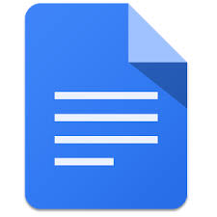 Google Docs

Google Docs allows to create and format text documents online using the browser. All changes are saved automatically. Several people can work on the same document and edit it in the real time. You can grant other people the right to edit document or only to view it and write the comments.

Functionality(Source: https://support.google.com/docs/answer/49008?hl=en):
- Upload a Word document and convert it to a Google document
- Add flair and formatting to your documents by adjusting margins, spacing, fonts, and colors — all that fun stuff
- Invite other people to collaborate on a document with you, giving them edit, comment or view access
- Collaborate online in real time and chat with other collaborators — right from inside the document
- View your document's revision history and roll back to any previous version
- Download a Google document to your desktop as a Word, OpenOffice, RTF, PDF, HTML or zip file
- Translate a document to a different language
- Email your documents to other people as attachments

Editability options

Download (possibility to download OER in editable version) | Online (possibility to edit OER online) | Limited access (possibility to edit OER for registered users) | Unlimited access (possibility to edit OER without registration) | Individual development (possibility to edit OER individually) | Collaborative development (possibility to edit OER collaboratively)
yes | yes | yes | yes | yes | yes

Editability

How to use
Here are the instructions how to Get started with Google Docs:
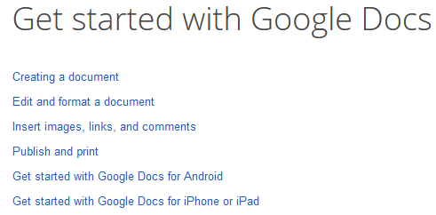

Here you can find description How to share Google documents and a short video (2:32) about sharing the document:
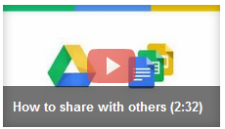

2.1.2 ICT tools for presentations

In this chapter we will overview several ICT tools that can be used to develop/adapt OER in presentation format.

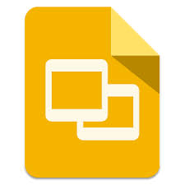Google Slides

Google Slides allows to create and format presentations online using the browser. All changes are saved automatically. Several people can work on the same presentation and edit it in the real time. You can grant other people the right to edit presentation or only to view it and write the comments.

Functionality (Source: https://support.google.com/docs/answer/49008?hl=en)
- Create and edit presentations
- Edit a presentation with friends or coworkers, and share it with others effortlessly
- Import .pptx and .pps files and convert them to Google presentations
- Download your presentations as a .pdf, .ppt, .svg, .jpg, or .txt file
- Insert images and videos into your presentation
- Publish and embed your presentations in a website

Editability options

Download (possibility to download OER in editable version) | Online (possibility to edit OER online) | Limited access (possibility to edit OER for registered users) | Unlimited access (possibility to edit OER without registration) | Individual development (possibility to edit OER individually) | Collaborative development (possibility to edit OER collaboratively)
yes | yes | yes | yes | yes | yes

How to use
Here are the instructions how to Get started with Google Slides:

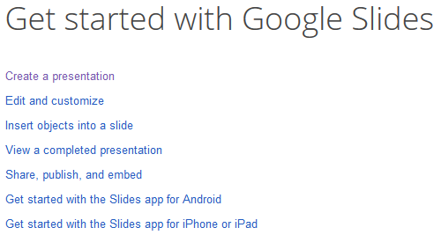

Here are some Basic information how to work with google slides in PDF format.

Here you can find description How to share Google documents and a short video (2:32) about sharing the document:

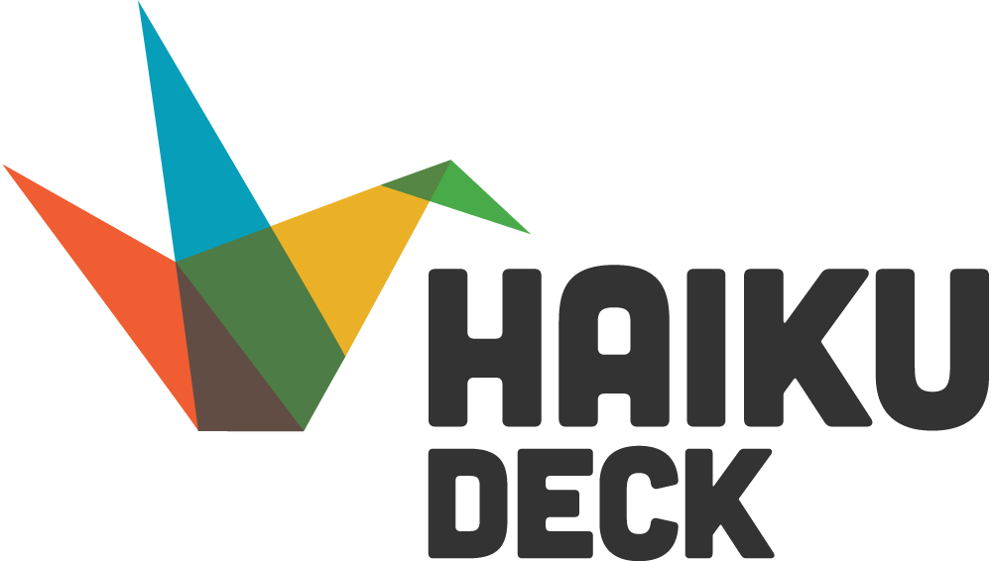

Slideshare with Haiku Deck integration
SlideShare is free tool for your presentations, the registration is needed. You can upload your PowerPoint slides, documents, images or other type of presentations to the platform. You can also upload files from your Google Drive, Dropbox, OneDrive, Gmail, etc. After successful upload of your presentation you can choose which Creative Common license you will use for your work and will your presentation be private or public. You can share your presentations with your friends, colleagues, embed to your blogs, courses and webpages.

Another great feature of SlideShare is Haiku Deck integration. Haiku Deck is very popular and free tool which allows you to create presentations online. You can use computer or iPad app to create a presentation. Tool is very easy to use, the most valuable feature is huge image gallery consisting of millions images which already comes with Creative Commons licenses so you can use these images for your presentations. You can choose various theme templates which best suits your presentation. Also you can export presentation to Slideshare, PDF or even to PowerPoint for free.

Functionality:
- Create a presentation
- Share on social networks such as Facebook, Google+, etc.
- Embed to websites, blogs, courses, etc.
- Export to other formats (PDF, PPT)
- Images gallery with Creative Commons license

Editability options

Download (possibility to download OER in editable version) | Online (possibility to edit OER online) | Limited access (possibility to edit OER for registered users) | Unlimited access (possibility to edit OER without registration) | Individual development (possibility to edit OER individually) | Collaborative development (possibility to edit OER collaboratively)
yes | no | no | no | yes | no

How to use
Here you can watch a video what is slideshare
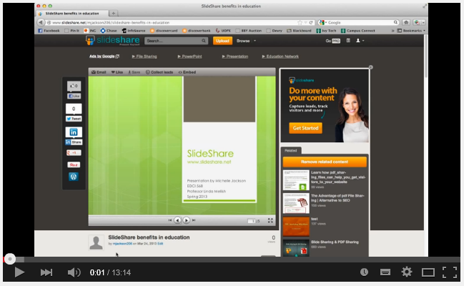

and How to create presentation with Haiku Deck
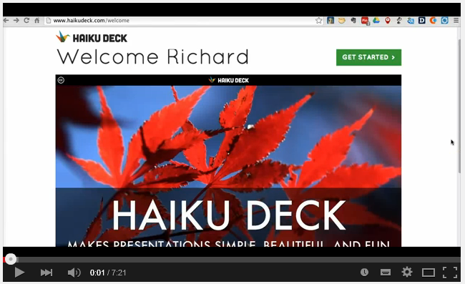
You can watch one more video about Presentation Tool Haiku Deck.
2.1.3 ICT tools for collaboration

Collaboration tools have the advantage of enabling several people to work on the same document or application. Here are some examples of collaboration tools.

Liveminutes is a tool for organizing collaborative work with your students, colleagues or co-workers. This is online tool available in all browsers. You can sign up to liveminutes.com for free and create a project where you can invite your students, colleagues or whoever you will be working with.

Using this tool you can create, upload, download various types of documents, presentations, pictures, graphs, etc. You can connect Liveminutes with your Google Drive or Evernote account and save your documents there. All project team members can collaboratively create or edit existing documents.

There is possibility to have a video or audio conference directly in browser without any additional software. You can arrange group work with your students and in the same time have a video conference and a collaborative work.

There is private chat and group chat where project members can discuss and follow all project activity (Picture 1). Also all members can write comments on documents, presentations and pictures if they have some concerns, questions or suggestions. You can share document or any other file with person who is not in project group by sending him direct link to liveminutes.com resource you are working on.

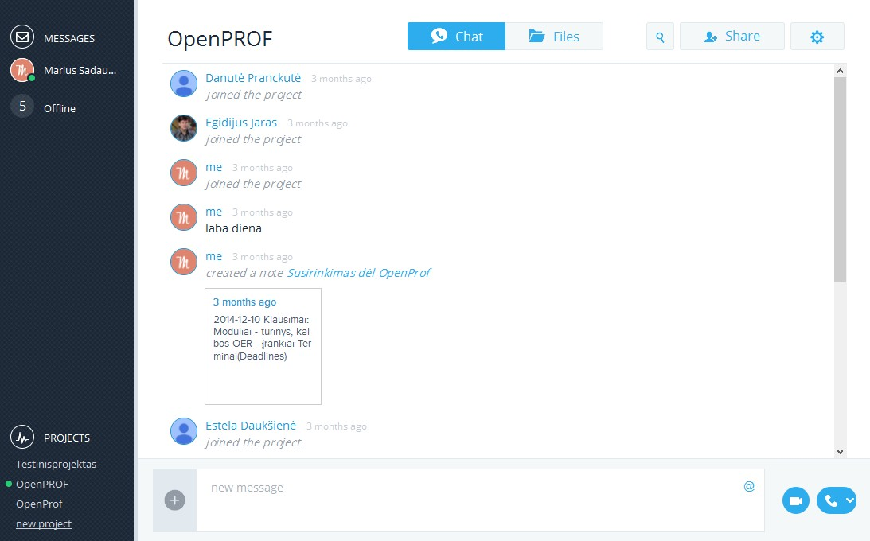
Picture 1. Project activity and group chat window.

Functionality:
- Create a project and invite people to it to collaborate
- Create notes
- Collaborative document editing
- Rich text editor
- Add comments to Documents/Pictures
- Upload files (documents/pictures/slides/etc.)
- Download files to computer
- Open documents from Google Drive
- Save documents to Google Drive
- Open and synchronize Evernote document
- Send private message
- Chat with whole project team
- Video conferencing in browser
- Share direct link to document for users who are not in the project

Editability options

Download (possibility to download OER in editable version) | Online (possibility to edit OER online) | Limited access (possibility to edit OER for registered users) | Unlimited access (possibility to edit OER without registration) | Individual development (possibility to edit OER individually) | Collaborative development (possibility to edit OER collaboratively)
yes | yes | yes | no | yes | yes

How to use
Here you can watch a short video How to work collaborative with Live Minutes
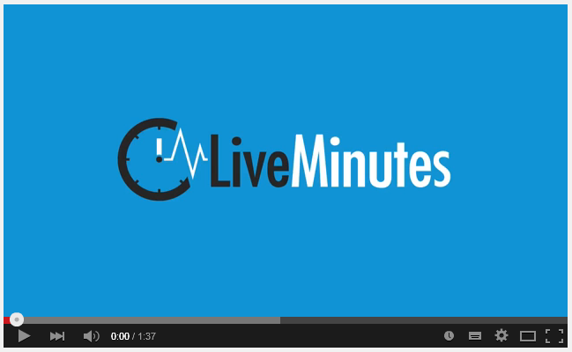

You can also read the presentation with print screens Using Liveminutes:
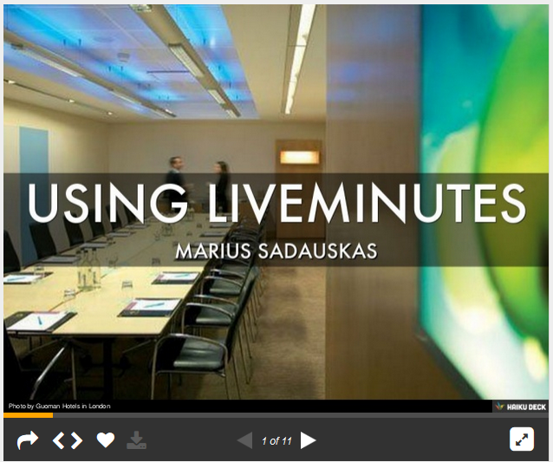
http://www.slideshare.net/msadauskas/using-liveminutes

Idea space
Another tool for collaboration is Idea Space, where various scenarios of collaboration can be performed. As description of Idea Space says “This platform is a place to find others to connect and work together on open education from the very beginning when bouncing around ideas to the final outcome – whether this is an open course or open textbook or anything else that helps to open up education.” it is suitable for creating a project, creating training material, OER or performing some kind of group task. For example teachers from different countries, different universities can join this platform, search for idea and if he thinks he would like to contribute he joins this group/idea and participate in creation process. Picture 2 illustrates how idea workspace looks like.
Also there is a repository of OERs where you can search for various OERs and download them: http://idea-space.eu/repository
Idea Space is free and can be accessible by address: http://idea-space.eu/ . This platform is created during LLP project “Open Educational Ideas and Innovations (OEI2)” No. 539990-LLP-1-2013-1-FI-ERASMUS-EQMC. More information about this project can be found at project website: http://project.idea-space.eu/

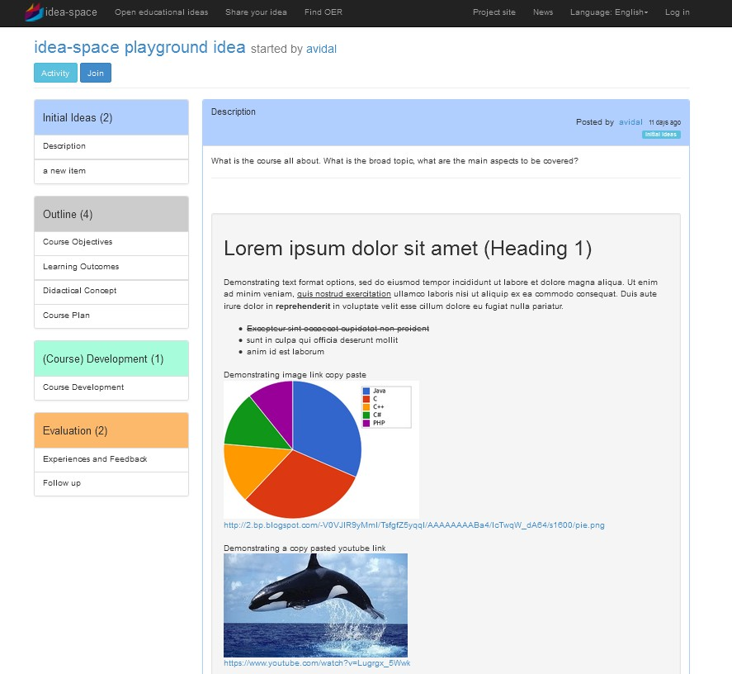
Picture 2. Idea workspace. http://idea-space.eu/idea/38/workspace

2.1.4 ICT tools for video/ audio

In this chapter we will overview some ICT tools that can be used to develop/adapt OER in video format.

Wevideo is a tool for video creation using just your computer and the internet. You can use it for free or buy a monthly subscription to get additional features, more space for your videos and exporting minutes. Your video can be exported to Wevideo player, Youtube, Vimeo, Google drive and downloaded as mp4 video file.
Wevideo tool is easy to use. It is based on drag and drop technique and very easy to understand. This tool can be used for various scenarios:
- you can create your own digital story,
- create a beautiful presentation for your students,
- subtitle videos,
- record your voice directly in Wevideo tool,
- other

To create a stunning video you can use a lot of different effects such as ken burns, zoom in, zoom out, sliding, spinning, etc. to create your video more attractive and thrilling. There are three different modes for creating your video: Storyboard, Timeline and Timeline Advanced. We suggest using Timeline as it is most practical and popular mode.

Using Wevideo tool you can share your work with other people. In this case your created video can be edited by people who are invited to your project work. This is great way to make a collaborative work or let other people to adapt your video to their own needs.

Functionality:
- Host video
- Combine multiple videos, audio tracks and images
- Record voice online
- Insert special effects
- Trimming/ lenghtenning/ cutting
- Add subtitles
- Share video with other people (to contribute or adapt your work to their needs)
- Download video
- Publish to various media sites such as Youtube, Vimeo and embeding in a website

Editability options

Download (possibility to download OER in editable version) | Online (possibility to edit OER online) | Limited access (possibility to edit OER for registered users) | Unlimited access (possibility to edit OER without registration) | Individual development (possibility to edit OER individually) | Collaborative development (possibility to edit OER collaboratively)
no | yes | yes | no | yes | no

How to use
Here you can find a video guide How to create a video with Wevideo:
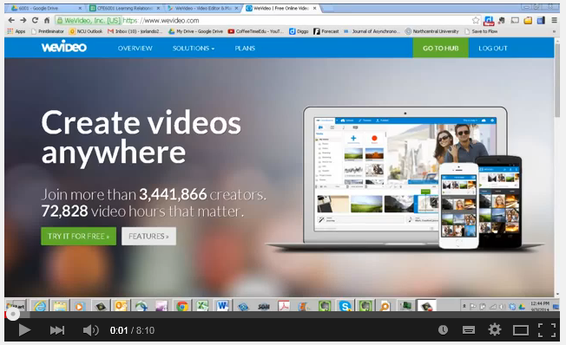
https://www.youtube.com/watch?v=bRZioKAFPPU

Here is a slide presentation Using Wevideo tool:
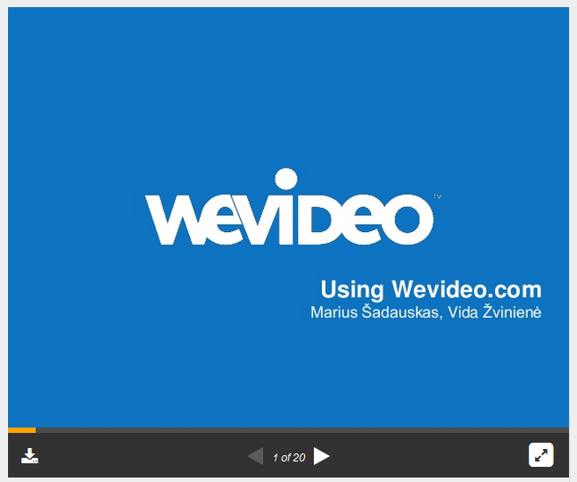
http://www.slideshare.net/msadauskas/wevideo-video-tool

Amara is free and open source tool to caption and translate your videos. Videos can be transcribed/translated collaboratively. Here you can see a short video presenting amara tool
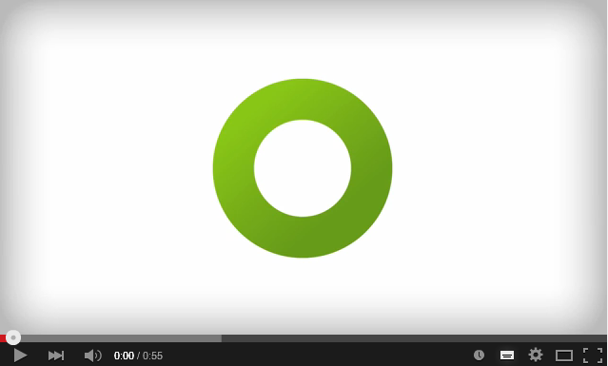

Functionality:
- Translate video
- Transcribe videos
- Download subtitles, captions, or transcripts
- Sync to Youtube
- Collaborate with other people

Editability options

Download (possibility to download OER in editable version) | Online (possibility to edit OER online) | Limited access (possibility to edit OER for registered users) | Unlimited access (possibility to edit OER without registration) | Individual development (possibility to edit OER individually) | Collaborative development (possibility to edit OER collaboratively)
yes | yes | yes | no | no | yes

How to use
You can watch a video guide How to translate a video
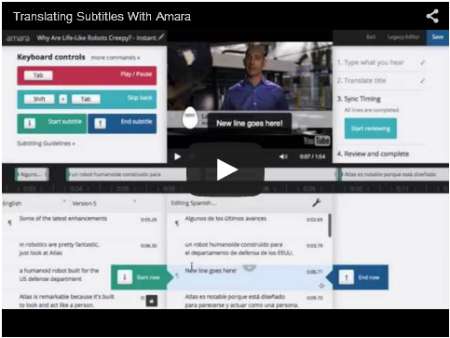

or How to transcribe a video
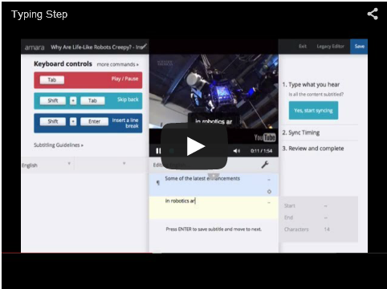

You can find more information at How-tos: Amara support centre webpage

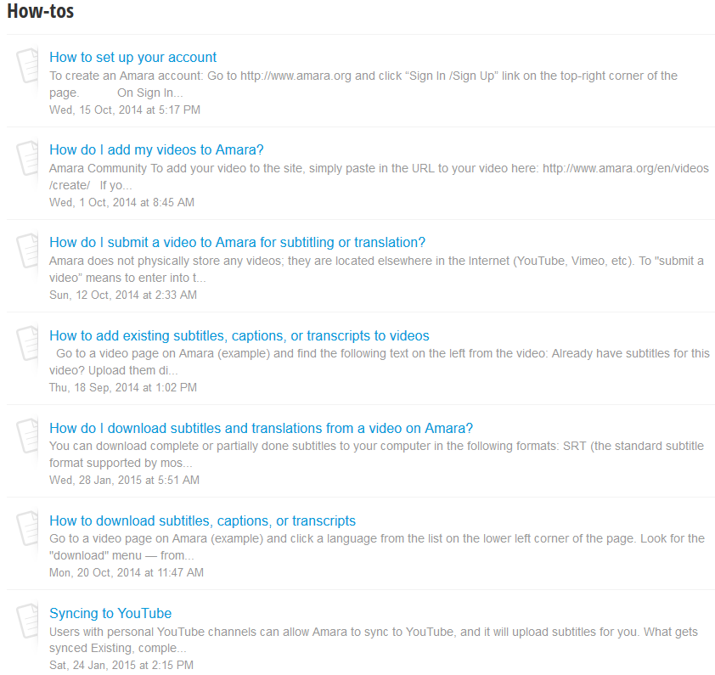

More information how to work with Amara tool available at Knowlwdgw Base webpage.

2.2 Choosing ICT tool for OER development/adaptation

During Assignment 1 you have set the requirements for ICT tool. Now you have to find the tool which corresponds to these requirements. You can use the tools presented in chapter 2.1 or you to find another one. There are several methods of finding appropriate ICT tool for OER development/adaptation:
- Use tools that you already know. Think about the tools that you already know for the development selected type of documents. Review “Requirements for ICT tool” table and think about their functionality. If you’ll find the tool using this option you’ll save your time, because you will not have to spend time getting know a new tool. If the tools that you already know do not meet your requirement or you want to gain experience using new ICT tool go to one of the further options.
- Use search engines (ex.: Google, Bing, Yahoo) to find ICT tools for selected type of OER development/adaptation. You can use advanced search option (ex.: Google Advanced Search) to enter your keywords. Use specific keyword phrases to locate the most relevant information.
- Use Web 2.0 tools databases to find ICT tools for selected type of OER development/adaptation. Here are some examples of web 2.0 tools databases:
  - Go2web20 Online tools and applications
  - Web 2.0: Cool Tools for Schools
  - ICT with Miss C
  - ICT by Teachers
  - TeachersFirst Edge

ICT tools in such databases usually are provided within the categories and this makes the search easier. In Picture 3 you can see the example of Web 2.0 tools database.

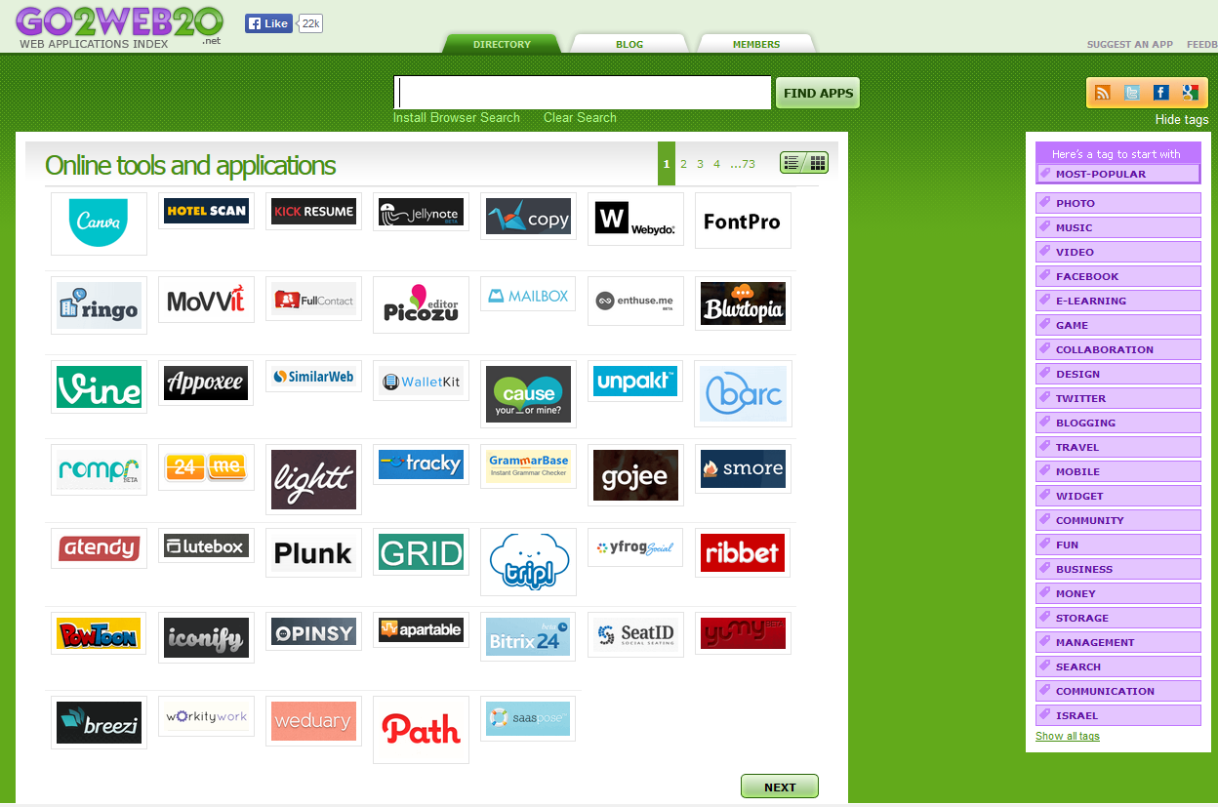
Picture 3. Go2Web20 web applications

Assignment 2 will help you to choose the ICT tool for OER development adaptation.

Assignment 2. Choosing ICT tool for OER development/adaptation
The aim of the assignment: having implemented this assignment, you will be able to choose ICT tool for development/adaptation your OER. Using this ICT tool you will have to develop/adapt your OER during the next Assignment 3.
Tasks:
- Find several ICT tools for selected type of OER.
- Evaluate their functionality and editability options (using the document that you filled in during Assignment 1)
- Choose ICT tool that most fits to your needs
- Explore how to use the tool
- Present the ICT tool to your peers.
The result expected.
ICT tool for OER development/adaptation is chosen according the functionality. Chosen ICT tool is presented to peers. Feedback from the audience is received.

After you made the decision on the ICT tool that you will use for developing your OER and explored how to use it it is time to develop/adapt OER.

Assignment 3. Developing/adapting OER using ICT tool
The aim of the assignment: having implemented this assignment, you will be able to develop OER using chosen ICT tool.
Using the ICT tool that you have chosen during the Activity 2 develop/adapt your OER.
The result expected.
OER is developed/adapted using ICT tool.

Unit 3. Licensing OER using Creative Commons
(this Unit is adaptation of "Marking your work with a CC license", “Publish” and “Best practices for attribution” all by Creative Commons, used under CC BY )

This unit focus on licensing your OER with Creative Commons. Having successfully completed this Unit, you will be able to:
- to choose the specific CC license to developed/adapted OER
- to mark developed/re-used/adapted OER with CC licence
During Assignment 4 you will choose the licence for developed/adapted OER and during Assignment 5 you will mark your OER with the chosen license.

3.1 Creative Commons licensing types

During Activity 3 you have developed your educational resource. In this chapter we will learn how to make it Open. The key to making your educational resource open is the License. Creative Commons is the most popular and easy to use licensing system for OER. Standard Copyright © license is very strict and is not suitable for OER which intention is to be Open and free to use, adapted and/or shared with other. That is why Creative Commons licenses are used to license OER’s. Creative Commons changes standard “All Rights Reserved” to “Some Rights Reserved” where creator chooses how his work can be used.

In the following short video developed by Creative Commons you will learn about the rules of using materials available on the internet under Creative Commons licenses.

What is Creative Commons (video)
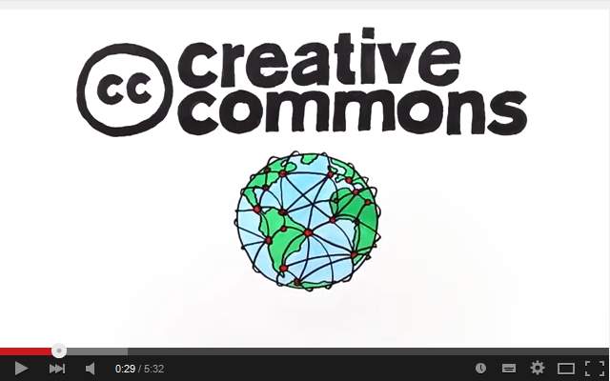
https://www.youtube.com/watch?v=AeTlXtEOplA
Or you can view slideshow Presentation about Creative Commons and licenses types to get the information about Creative Commons and licensing types:

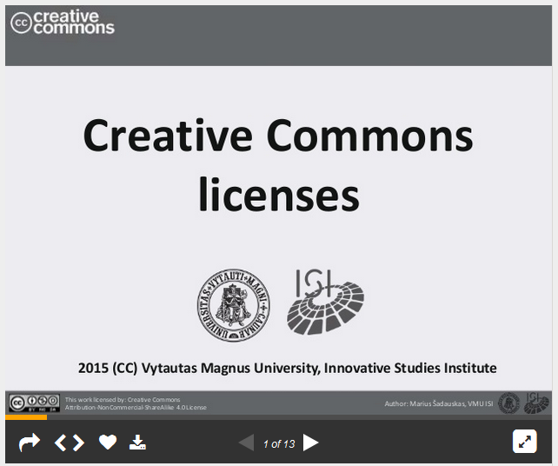
http://www.slideshare.net/msadauskas/creativecommons-licenses-types-and-licensing

There is six main licenses types which allows creators to publish their work, however if they are using someone else work and it is licensed as ShareAlike, they have to follow this and share their work with the same license type.

Assignment 4 Choose the license for developed/adapted OER
Choose the license for your developed/adapted OER according to provided training material, video presentation and slideshow.
Remark: If your work is an adaptation of a work licensed under either CC BY-SA or CC BY-NC-SA, then your derivative work must be made available under the same license as per the ShareAlike condition.)
The result expected.
The specific CC license for developed/adapted OER is chosen.

3.2 Marking your OER with CC licence

During the Assignment 4 you have chosen a CC license for your OER. Now you have to mark your OER that people would know it. A good rule is to use the acronym ALM, which stands for Author, License, Machine-readability:
- Author (who is the author of developed OER and should be credited using it?)
- Licence (name the specific CC license OER is under and link to it), eg. Creative Commons Attribution 4.0 License with a link to http://creativecommons.org/licenses/by/4.0/
- Machine readability (allows search engines and software systems to detect which CC license your OER is under). You can use license chooser tool, to get the machine-readable html code, which you can paste into web pages. You can also upload your OER to a content sharing platform that supports CC licensing and takes care of the machine-readability.

Note: when you add a CC license to your work, you are only granting permissions to the rights you hold in the work. So if your work is a derivative of another creator's CC-licensed work, or otherwise incorporates third-party content under fair use or other exceptions, then you should make a note of that for your users. Your CC license only ever covers the rights you have in the content you create, and never other content by third parties.

You can use the tool http://creativecommons.org/choose/, which will help you to licence developed OER.

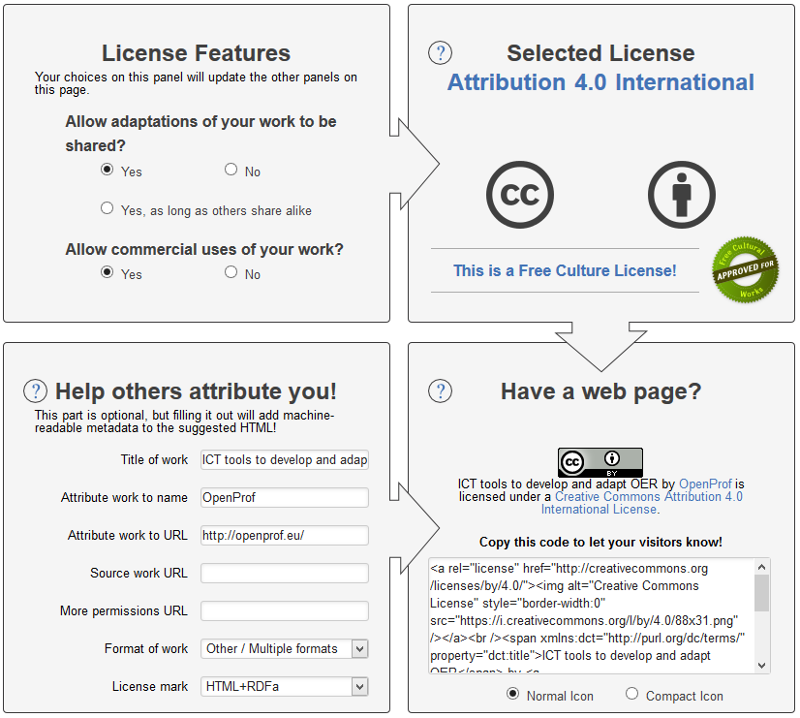
http://creativecommons.org/choose/

- In the ”License Features” panel select your answer to the questions: “Allow adaptations of your work?” and “Allow commercial uses of your work?”. Your choices in this panel will update the other panels of the tool.
- The "Selected License" panel displays information about the license that was described in the "License Features" panel. Changing the values in the "License Features" panel will update the information displayed here.
- Filling “Help others attribute you” part is optional, but filling it out allows people coming to the license deed from your page to see information about how to attribute your work. It will add machine readable metadata to the suggested HTML and allows search engines to index additional information about your work.
- The HTML provided in “Have a web page” panel may be pasted into your website to display which license applies to your work, as well as attribution information. The HTML combines information provided in the "License Features" panel and the "Help others attribute you!" panel. The HTML also contains RDFa metadata, which allows search engines to accurately determine which license your work is under, and how you want to be attributed.

Below you can find some examples of how to mark your OER with the CC license.

Example: Website
Copy and paste the HTML code into your webpage or website. You can edit the descriptive text to suit your needs.

Example | Analysis
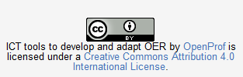 | Author: clearly specifies that OpenProf is the party that should be credited  License: clearly specifies the CC BY license with a link.  Machine readability: yes (copied and pasted code from the license chooser)

If all of the resources you are publishing on a single website are licensed under the same CC license, it makes sense to paste the HTML code into your website’s template (e.g., in a footer or sidebar area). After saving the template, the chosen license information should appear everywhere on your site. Whether you add license information to a single page or an entire site, once live on the Internet, the license information will be displayed and the machines will be able to detect the license status automatically.

Example | Analysis
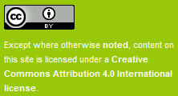 | Author: Since the license is for the CC website as a whole, which includes multiple authors, one attribution party is not specified. Instead, it is clarified in the Terms of Use (linked in the footer on the left) who owns what content.  License: The specific CC license is noted (CC BY) and linked.  Machine-readability: yes (copied and pasted code from the license chooser)

Example: Document
For documents that are meant to be shared offline, use a title and/or copyright page to include the copyright notice and CC license information. You can obtain suggested text using the license chooser. In the 'Help others attribute you!' box, select 'Offline' in the drop-down menu for 'License mark'. Instead of html, you will receive the following text which you can edit as needed:

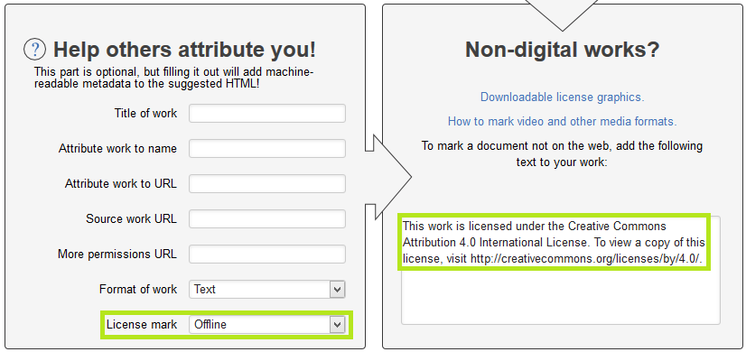

You can also download the corresponding CC license icon at CC downloads page.

Example | Analysis
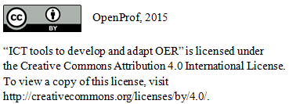 | Author:  License: The specific CC license is noted (CC BY) and linked.  Machine-readability: no, it’s offline

Example: Presentation
Below there are two good examples of licensing presentation. The slide of a first example appears at the end of Jane Park's presentation called "Creative Commons Version 4.0 for Education" at Slideshare. The slide of the second example appears at the end of Jane Park's presentation called "Creative Commons for TAACCCT Grantees" at Slideshare.

Example | Analysis
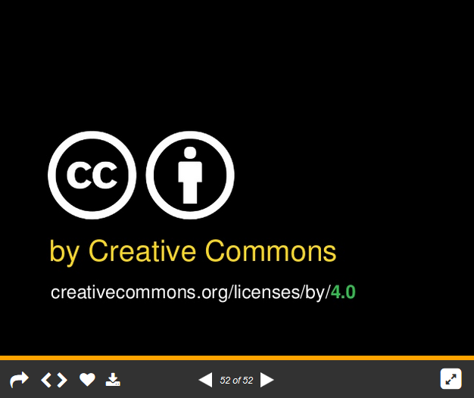 | Author: “by Creative Commons”  License: The specific CC license is noted (CC BY) with a link provided,.  Machine-readability: yes, because it was uploaded to Slideshare, a slide-sharing platform that supports CC licensing.
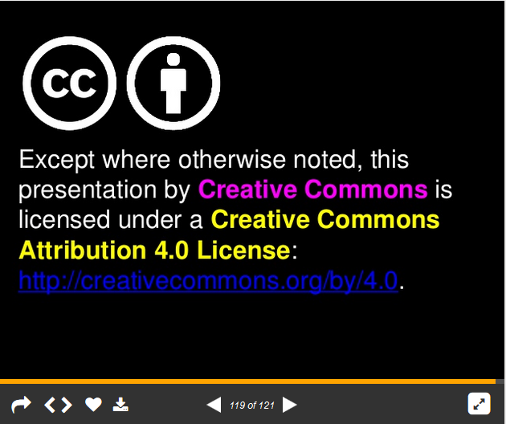 | Author: “Except where otherwise noted, this presentation by Creative Commons”  License: The specific CC license is noted (CC BY) with a link provided,.  Machine-readability: yes, because it was uploaded to Slideshare, a slide-sharing platform that supports CC licensing.

Example: Video
At the end of your video you can add a CC video bumper for a 2-5 second copyright frame:
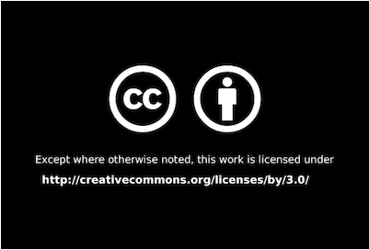

Noting third-party content in your work
You can use CC-licensed materials as long as you follow the license conditions. One condition of all CC licenses is attribution. A good rule is to use the acronym TASL, which stands for Title, Author, Source, License:
- Title (what is the name of the material?) (if provided)
- Author (who owns the material?)
- Source (where can I find it?)
- License (how can I use it?) - name specific CC licence and provide link to it

Here is a photo. In the table below you can find some examples of how people might attribute it.
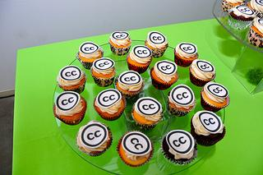

Examples of attribution
Ideal attribution | Pretty good attribution | Incorrect attribution
"Creative Commons 10th Birthday Celebration San Francisco" by tvol is licensed under CC BY 2.0 | Photo by tvol / CC BY | Photo: Creative Commons
Because:  Title: "Creative Commons 10th Birthday Celebration San Francisco"  Author: "tvol" - linked to his profile page  Source: "Creative Commons 10th Birthday Celebration San Francisco" - linked to original Flickr page  License: "CC BY 2.0" - linked to license deed | Because:  Title: title is not noted (it should be) but at least the source is linked.  Author: "tvol"  Source: "Photo" - linked to original Flickr page  License: "CC BY" - linked to license deed | Because:  Title: title is not noted.  Author: Creative Commons is not the author of this photo.  Source: no link to original photo.  License: There is no mention of the license, much less a link to the license. "Creative Commons" is an organization.

Publishing OER at CC-enabled content sharing platforms

One way to increase visibility and access to your OER is to share it with an existing community. Many content platforms have already enabled CC licensing, making it easy to indicate the license along with other information, such as who to attribute. Here are some examples of publishing platforms categorized by media type:

Media type | Content sharing platform | Description and publishing instructions
Document |  | Scribd is a community for uploading and sharing documents that has enabled CC licensing.  How to publish on Scribd
Presentation |  | SlideShare is a community for sharing presentations, documents, and PDFs under CC licenses. Various professionals are linked through sub-communities via LinkedIn, Facebook, and Twitter.  How to publish on SlideShare
Video |  | Vimeo is a high quality video-sharing website for creators that has enabled CC licensing.  How to publish on Vimeo
 |  | YouTube is a popular video-sharing platform that has enabled the Creative Commons Attribution (CC BY) license as an option for creators to license their work when uploading their videos. YouTube has created a tutorial on how to mark your video as CC BY when uploading videos to its platform at http://www.youtube.com/t/creative_commons.
Audio |  | SoundCloud is a music and audio sharing community that allows artists to upload its works under the full suite of CC licenses. Its set of tools integrate nicely across the web, with adoptions from well known artists and labels.  How to publish on SoundCloud
Jamendo is a music platform offering artists the ability to promote, publish, and be paid for their music made available for download under Creative Commons and the Free Art licenses.
How to publish on Jamendo
Table 5. CC-enabled content sharing platforms

You can find more CC-enabled Content Directories here.

Assignment 5 Marking developed/adapted OER with CC license
The aim of the assignment: having implemented this assignment, you will be able to mark developed/adapted OER with CC licence.
You can use license chooser tool to get suggested text and/or html code. Marking your OER, please, take into account:
- Author
- Specific CC licence with link to it
- Machine readability (if applicable)
The result expected.
Developed/adapted OER is marked with CC licence. Author of OER and specific CC licence with link to the description is provided.

