Training material on
OER and Sustainability Models
Authors: Lina Morgado, António Teixeira, Universidade Aberta
Contributors: OpenProf Partners

Having successfully completed all training material, you will be able to:
- understand the approach of open movement
- describe/identify specific characteristics of OER
- find, select and use/reuse/make one OER
- analyse case studies of sustainable models of OER

Unit 1. Understanding the ‘open education approach’ and OER’s characteristics

This Unit focuses on understanding the approach of the open education movement. Having successfully completed this Unit, you will be able to:
- understand the open education movement
- describe/identify specific characteristics of OER

With Assignment 1 you will be able to apply the theoretical concepts studied on the characteristics of the different concepts in open approach and OER which will help you to understand and, eventually, play a role in open education.

  - Overview of the open education approach

The concept of “open education” is not recent. In fact, the concept of “openness” in education won a new term with the development of information and communication technologies, in the late twentieth century and in particular with the Internet.
There isn´t a consensual definition but the concept of “open education” became popular after 1970 with the beginning (and creation) of the Open Universities movement. It is described and used in various contexts, which involve a series of practices, some more traditional and others more recent (Santos, 2012).
The concept of “open” was related with the access variable because this model hasn´t got any kind of prerequisites.
With the evolution of the context, the term also evolved. In fact, we can call the past decade as the "open decade" because it witnessed the expansion of the opening movement of access to knowledge in its many forms (open source, open access, open content and open practices).
In Fig 1 we can observe some of the initiatives of open education.

Fig. 1 - Role of openness in education: a historical reconstruction (Peter & Deimann, 2013)

  - Concepts and Characteristics of OER

In this chapter you will find the presentation of the concepts related with OER, work with some OER material and an Assignment on OER.
We will present some basic concepts related to the notion of “openness” namely open access, open source, open content, open practices and open courses.
Open Access - the opening sentence of the Budapest Open Access Initiative encapsulates what the open access movement and is a public statement of principles related to open access.
“By 'open access' to this literature we mean its free availability on the public internet, permitting any users to read, download, copy, distribute, print, search, or link to the full texts of these articles, crawl them for indexing, pass them as data to software, or use them for any other lawful purpose, without financial, legal, or technical barriers other than those inseparable from gaining access to the internet itself…“ (http://www.budapestopenaccessinitiative.org)

Open Source - referring to the use of free software, which movement was based on higher education. For example, Moodle (https://moodle.org) is an open source eLearning platform, a software package designed to help educators easily create quality online courses.
Open Practices - characterized by the combination of features with use of open architectures of open learning, with the aim of transforming the twenty-first century learning environments, in which educational institutions, adult learners and citizens have the opportunity to build their learning pathways throughout life, in an autonomous and self-directed way.
Open Courses, courses that are offered online, with various payment models or completely free.
There are several definitions of OER. We selected some of the most relevant for the understanding of this field.
UNESCO (2002) in Forum on Open Courseware
teaching, learning and research materials in any medium, digital or otherwise, that reside in the public domain or have been released under an open license that permits no-cost access, use, adaptation and redistribution by others with no or limited restrictions. Open licensing is built within the existing framework of intellectual property rights as defined by relevant international conventions and respects the authorship of the work.

William and Flora Hewlett Foundation
teaching, learning, and research resources that reside in the public domain or have been released under an intellectual property license that permits their free use and re-purposing by others. Open educational resources include full courses, course materials, modules, textbooks, streaming videos, tests, software, and any other tools, materials, or techniques used to support access to knowledge.
Commonwealth of Learning (http://www.col.org)
materials offered freely and openly to use and adapt for teaching, learning, development and research.

WikiEducator ( www.wikieducator,org)
educational resources (lesson plans, quizzes, syllabi, instructional modules, simulations, etc.) that are freely available for use, reuse, adaptation, and sharing.
The core characteristics of OER are the following (Schaffert & Geser, 2008; OLCOS Roadmap, 2012):
Open Access | Content is provided free of charge for educational institutions, content services and users such as teachers, students and lifelong learners.
Open Format | Content is produced in open format with functionalities that allows for easy re-use.
Open License | Liberal licenses to enable re-use combine and re-purposing of content.
Open Software | Produced with open- source software.

In Table 1 we present some examples of OER based on Content, Tools and Resources.
Based on | Examples
Content | Complete Courses, Course Materials, Content Topics, Study guides, Journals, Syllabus, Books, Videos, Images, Assessment Tools, Quizzes, Games, Simulations, etc.
Tools | Software and Services for creation, delivery, use of open learning content, search and organize content; Content Management and Learning Systems (CMS, LMS), content development tools and online learning communities.
Resources | Licences, Creative Common Licences
Table 1- Examples of OERs

Another aspect to consider is the advantages and disadvantages in the adoption and use of OER, depending on the point of view. These are summarized in Table 2, along with arguments from both points of view.

Advantages to OER | Disadvantages to OER
Freedom of access, both for yourself and others | Varying degrees of time commitment
Freedom from proprietary systems and corporations | Teachers sometimes not rewarded by the system for their efforts
Encourages pedagogical innovation | Starting large projects can be difficult
Lowers costs to students | Some projects require startup resources
Potential publicity | Quality varies
Contribution to a community | May not meet accessibility requirements for persons with disabilities
Method of collaboration | Need to check accuracy before use
Helpful to future educators | May need a high degree of customisation (called localisation in the OER community)
Potentially beneficial to developing nations | Technical requirements vary and some require you to use a particular software
Avoids ‘vendor lock-in’ or a situation in which you have to use one company's products | Requires varying degrees of continual financial support
 | Some institutions may be concerned about ‘giving it away’
Table 2- Advantages versus Disadvantages, WikiEducator’s OER Handbook for Educators

We can measure the openness of a content in terms of the rights a user of the content is granted (Wiley, 2007a). The 4Rs Framework is a great tool and describes the four most important rights when we work with the concept of OER:

- Reuse - the right to use the application without changing the original form (display an exact copy);
- Review - the right to adapt, adjust, modify, or change the resource (translation, localization);
- Remix - the right to match the original or adapted resource with other resources to create something new (mashup);
- Redistribute - the right to share copies of the appeal, adaptations or remixes.

Another important issue related with “openness” is the differences between Big OER and Little OER (Weller, 2010).
What is a Big OER?
"Big OER" are institutional projects, consortia and organizations that have the goal to have the learning content available. Many of the big OERs have explicit learning aims or an intended level They are institutionally generated and have some characteristics:
- Usually high quality (quality control)
- Explanation of planned learning (teaching aims, uniform style)
- Reputation
- Relatively high cost
An example of a Big OER is OpenLearn (http://www.open.edu/openlearn/). OpenLearn provides free educational resources (Interactives, games, video, podcasts or entire online courses).

What is a Little OER?
"Little OER" are produced by individuals and are low cost resources. They can be produced by anyone; they may not have teaching aims and are usually low quality. They are distributed through online free services, such as blogs, Slideshare, YouTube, Scribd, and so on.
- Produced individually, not necessarily by educators
- May not have explicit educational goals
- Low cost
- More adaptable
- Variable quality
An example of a Little OER could be a blog or a presentation for a session or a recorded lecture.

Assignment 1. Concepts and Characteristics of OER
The aim of the assignment: having understood the open education approach in this assignment, you will be able analyse some concepts of OER.

Tasks:
- analyse the timeline of open education in this site: http://timemapper.okfnlabs.org/okfnedu/open-education-timeline
- select three events or initiatives that represent the concepts of open education, open course and open content.
- organize a new timeline for your country and introduce three activities that are related with the OER movement.
- choose an open resource and, with the 4 Rs Framework, decide if you can adapt and reuse the resource.
- select from the web or a repository a Big OER and a Little OER.

The result expected.
After undertaking these tasks, you will have developed an understanding on the diversity of concepts and activities on what an OER can be.

Unit 2. Find, Select, Use and Re-use OER

This Unit focuses on find, select, use and re-use OER. Having successfully completed this Unit, you will be able to:
- find, select and use/reuse/make an OER

With Assignment 2 you will be able to apply some guidelines to find, select and use/reuse/make an OER and integrate it in a learning situation.

2.1 Find and Select an OER: Searching Repositories of OER and other Online Sources

In the next chapter you will find several examples of Repositories of OER where a countless abundance of OER that could be used are deposited, as well as other online sources and initiatives that are important for searching OER for use or re-use. There are also several initiatives and projects throughout the world that work as repositories of OER. It´s possible to find and select OERs employing different methods: 1) browsing on topics and subjects; 2) recommendations from colleagues and/or personal friends; 3) searches within organizations with reputation; 4) searches through well ranked resources (Clements & Pawlowski , 2012).
.

Repositories

There are different types of repositories in the world that store open content and hosts collections of OERs. We selected some of them as examples of Open Educational Resources Repositories. All of the resources are free and can be used as they are or adapted, remixed, that is: they can be used or re-used.

Name
Ariadne | http://www.ariadne-eu.org/ | European Union
Economics Network Online Learning and Teaching Materials | http://www.economicsnetwork.ac.uk/links/othertl.htm | United Kingdom
FREIburger Multimedia Object Repository | http://freimore.uni-freiburg.de/ | Germany
Lab Space | http://labspace.open.ac.uk/ | United Kingdom
Merlot | http://www.merlot.org | United States
National Learning Network | http://www.nln.ac.uk/ | United Kingdom
OpenLearning | http://www.open.edu/openlearn/ | United Kingdom
OER Commons | http://oercommons.org/ | United States
OER Online Archive | http://www.archive.org/ | Undefined
Table 3-OER Repositories

Institutional Initiatives

OCW - The central idea of this project is the publication of web materials used in classroom teaching at MIT, such as notes, curricula, bibliographies and simulations, as well as lessons in video and audio. It is possible to use them or adapt and re-use.
OpenLearn - An initiative launched in the UK, the Open University UK (OUUK) is the OpenLearn, which began in 2006, funded by The William and Flora Hewlett Foundation (foundation that stands out for leading numerous OER initiatives). The main difference between this initiative and the MIT OCW is that this does not only provide a selection of materials available for free use, but it also provides tools to help all those who wish to develop and publish educational resources, with the goal of simultaneously build communities of students and educators through various tools and strategies.
OpenCourseWareConsortium - The relevance of this initiative is closely related to its international scope, the OpenCourseWareConsortium (OCWC). The OCWC is a community with members from all around the world, representatives of more than 100 higher education institutions and associated organizations, which assume a commitment to disclosure of OER and its impact on global education. Consortium members use a shared publishing model; each member undertakes to publish a minimum of ten courses in a format that meets the definition of OCW. A special feature of this initiative is that of promoting the sharing between institutions, which allows developing a common assessment framework to all members of the Consortium, in trying to establish quality criteria.
Open Learning Initiative - The Open Learning Initiative, sponsored by Carnegie Mellon University, was launched hoping to provide online learning environments as an alternative to traditional education, promoting greater interaction between students and content and providing students with more frequent feedback. The courses developed under this project were based on principles of cognitive learning, which stress the importance of interactive environments and solving authentic problems, supported by an efficient technological interface with innovative features, such as intelligent tutoring systems, virtual laboratories, experiences and group simulations. The initiative also takes aim at building a community with an important role in the development and improvement of courses, a concept that opens the way for the importance of open educational practices.

2.2 Use, Re-used or Produce an OER

In the next chapter you will find three typical scenarios for using OERs in learning situations.

Scenario1 – Use a resource in its original form

There is an enormous abundance of OERs. Some resources and materials may only be used in the original form. So, after searching in the repositories, collections, institutional initiatives and others sources that store open content, you can find what you need.
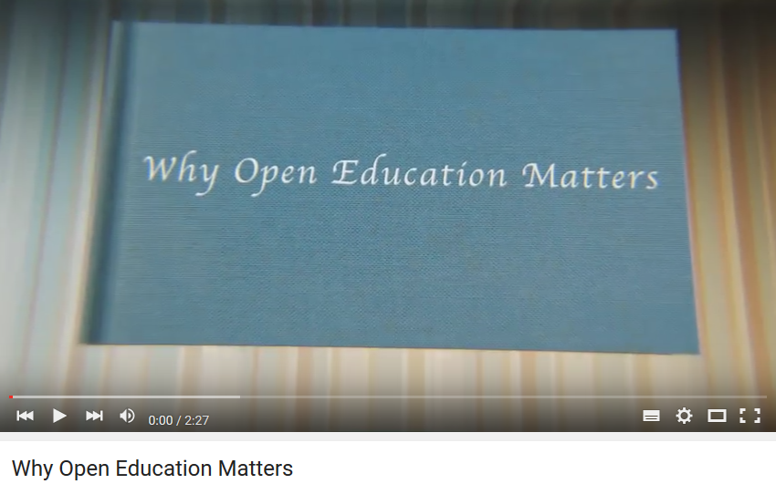
Fig 2- Video selected and used as it is
[Blake, D. (2012). Why Open Education Matters,
https://www.youtube.com/watch?v=gJWbVt2Nc-I&index=1&list=PL741678F352148469]

Scenario 2 – Modify, Remixed and Use an OER

Some resources can be modified, adapted, remixed and re-used and redistributed. In some cases they are modular, allowing the users to modify some parts and re-mixed, using other combinations to address other learning outcomes or learning activities. These interventions could be done by the author or by the users of the OER and with ICT tools. Use this Introductory Guide [How to Search for Open Educational Resources, http://elearninginfographics.com/how-to-search-for-open-educational-resources-infographic/] and this video [https://www.youtube.com/watch?v=CUVW5fhQP2k] to support your needs and guide your journey.

Fig 3- Video modify, remixed and use OER
[OERIPR Support, D. (2012). Turning a Resource into an Open Educational Resource, OER
https://www.youtube.com/watch?v=CUVW5fhQP2k]

Scenario 3 – Produce an OER

To produce an OER you should decide what tools or electronic resources to use, as well as the formats (multimedia, text, etc.). In any case you should decide under what type of licence to support the openness of the content produced - a Creative Commons Licences other or similar licence. This is the key aspect to transform the resource created in an open educational resource. You can find more information about Licences in the Training Material 2 where you can learn about this subject.
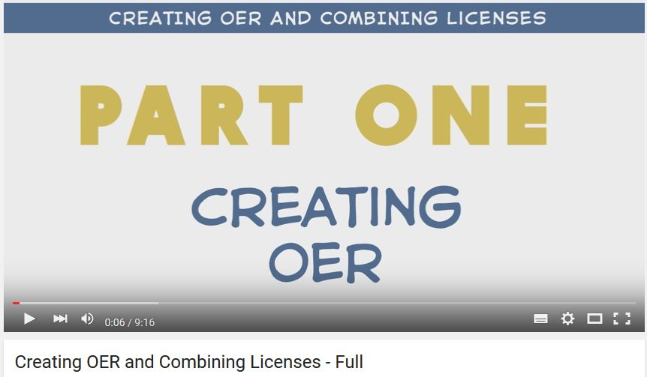
Fig 4- Video produce an OER
[OGRepository (2012). Creating an OER, https://www.youtube.com/watch?v=Hkz4q2yuQU8 ]

Assignment 2. Search, select and adapt an OER
The aim of the assignment: having completed this assignment, you will be able to search, select and adapt an OER. Follow this guide to implement the assignment: [http://elearninginfographics.com/how-to-search-for-open-educational-resources-infographic/]

Tasks:
- choose a repository or an online source where you can find open educational resources that can be adapted, remixed and re-used.
- select one resource.
- adapt the resource to use in a training situation ( introduce a modification, re-order, mix with other content, and so on).
- choose the same type of Licence.

The result expected.
- After undertaking these tasks, you will have developed skills to find, select and use/reuse an OER.
.

Unit 3. Sustainable Models of OER

This unit focuses on Sustainable Models of OER. Having successfully completed this Unit, you will be able to:
- know three different cases of sustainable models of OER

- During Assignment 3 you will choose a case and discuss in a group the organizational view.

3.1 Sustainable Models for OER

There are numerous initiatives in the context of Open Educational Resources, with different models of organization and operation. Wiley (2007b) illustrates this diversity, identifying three sustainable models of OER, based on criteria such as size, organization and content creation, among other services. Sustainability is also linked to funding models or with business models that an institution, a group or an individual adopt to adopt, support or manage OER. Table 4 presents the 3 main Sustainable Models for OER considered as study cases in the world that adopted different approaches and the main differences between them.

 | Case 1  MIT | Case 2  USU | Case 3  Rice
Course production goals | All courses offered by MIT | Many courses offered by USU | Many courses offered anywhere
Control over courses produced | High degree of control | Small degree of control | Practically no control
Cost per course produced | USD 10 000 | USD 5 000 | USD 0
Organisation size | Large | Medium | Small
Table 4 - Models in use in OER initiatives (adapted Wiley, 2007b)

Case 1 ) MIT model:
Centralized responsibility of an organization (4.3 million / year), with a high degree of centralization and coordination in terms of organization and delivery of services, which work is developed mainly by paid employees under the project.
Case 2) the USU model
Hybrid (+ organization volunteer academic work) (127,000 / year) with a mix of centralization and decentralization, from the organization or the services, in which the work is distributed by paid staff, but also by several volunteers.
Case 3) the Rice model

: decentralized (collaborative, community) (very low value per course) almost entirely decentralized, whose services are also almost totally provided by volunteers.
Assignment 3. Choosing a Case of Sustainable Model of OER and discuss in a group or pair the organizational view.
The aim of the assignment: having completed this assignment, you will be able to understand the different sustainable models of OER.

Tasks:
- analyse the different models.
- adopt the point of view of one of the models for your organization.
- evaluate the possibility (or not) of adoption of the chosen model.
- present the solution to the others groups of peers.

The result expected:
After undertaking these tasks, you will have developed an understanding on different cases of sustainable models of OER.

References
Clements, K. I., Pawlowski, J. M. (2012). User-oriented quality for OER: understanding teachers’ views on re-use, quality, and trust. Journal of Computer Assisted Learning, 28, (1), 4-14.
Geser, G. (2012) (Ed) . OLCOS RoadMap, Austria, http://www.olcos.org/cms/upload/docs/olcos_roadmap.pdf
Peter, S. & Deimann, M. ( 2013), On the role of openness in education: A historical reconstruction, Open Praxis, vol. 5 issue 1, January–March 2013, pp. 7–1 http://openpraxis.org/index.php/OpenPraxis/article/view/23/8
Santos, I (2012). Educação Aberta: histórico, práticas e o contexto dos recursos educacionais abertos, in Santana et al.(Orgs). Recursos Educacionais Abertos, práticas colaborativas e políticas públicas, pp71-89, São Paulo: Casa da Cultura Digital
http://www.artigos.livrorea.net.br/wp-content/uploads/2012/05/REA-santos.pdf
Schaffert, S., & Geser G. (2008). Open Educational Resources and practices. eLearning Papers. 7, 1–10.
Weller, M. (2010). Big and Little OER. In Open Ed 2010 Proceedings . Barcelona: UOC, OU,
BYU. http://hdl.handle.net/10 609/4851
WikiEducator’s. OER Handbook for Educators, http://wikieducator.org/OER_Handbook
Wiley, D. (2007a). Openness, localization, and the future of learning objects. BCNet, Presentation. Retrieved from http://opencontent.org/presentations/bcnet07
Wiley (2007b). On the Sustainability of Open Educational Resource Initiatives in Higher Education, OCDE. Retrieved from http://www.oecd.org/edu/ceri/38645447.pdf

Links
How to Search for Open Educational Resources, http://elearninginfographics.com/how-to-search-for-open-educational-resources-infographic
Videos
Blake, D. (2012). Why Open Education Matters, https://www.youtube.com/watch?v=gJWbVt2Nc-I&index=1&list=PL741678F352148469
OERIPR Support, D. (2012). Turning a Resource into an Open Educational Resource, OER,
https://www.youtube.com/watch?v=CUVW5fhQP2k
OGRepository (2012). Creating an OER, https://www.youtube.com/watch?v=Hkz4q2yuQU8

